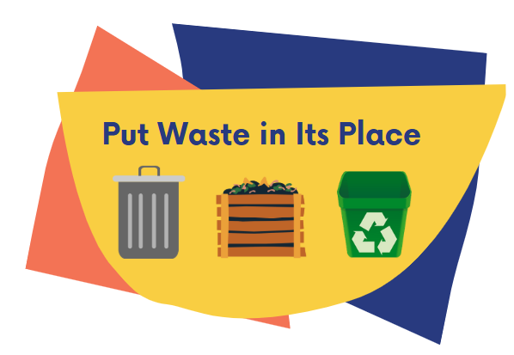
The 34th Annual
Ozark Rivers Earth Day
Poster, Trash & Graphic
Art Contest Sponsorship

Put Waste in Its Place

Yes! We will co-sponsor the 2025 Earth Day Poster, Trash & Graphic Art Contest for raising awareness in our youth to develop good waste management habits.
.
Co-sponsorship Levels: ___$25 ___$50 ___$75 ___ $ 100 ___ Other

Name/Institution: ____________________________________________________

Please provide contact information:

Contact Name: ________________________________________________________

Address: _____________________________________________________________

Phone Number: ________________________________________________________

Email Address: ________________________________________________________

Co-sponsors: please return a check or money order made out to Ozark Rivers SWMD and
mail it to the following address: Kathryn Hawes, MRPC, 4 Industrial Drive, St. James, MO 65559.
We would appreciate a response at your earliest convenience.

For media recognition, please submit an electronic file of your logo to be used in all
related promotions of the contest. If you have further questions, please contact
Kathryn Hawes at 573-265-2993 or khawes@meramecregion.org.
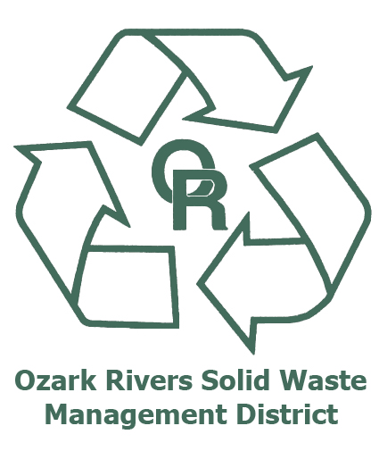




Disclaimer: Teachers from every school within our seven counties will be sent invitations to participate in this contest. However, we cannot guarantee that students from every town will participate or that a student from your hometown or county will place in any of the age categories.

