Priorities for 2022 ORSWMD Grant Cycle
This list of targeted materials is based on Missouri’s targeted materials list. Ozark Rivers has prioritized materials and project areas to address specific needs in the district — however all projects will be considered. Visit our website at ozarkrivers.org for a list of funded projects and detailed information/

High Priority Medium Priority_ Low Priority _
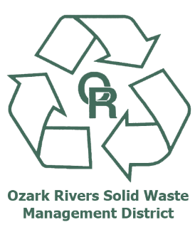
Household Hazardous Waste* Cardboard Ferrous Metals Old
Education Plastics (#s 1 & 2) Bi-metal containers
Scrap Tires Other paper (office paper, Yard Waste
Paint pasteboard, mixed paper, etc.) Non-Ferrous Metals
Electronic/appliance scrap Major appliances Lead-Acid Batteries
Construction &Demolition Waste Carpet and padding Old newspapers
Organic Waste (food waste) Mattresses School Lab Waste
Textiles Plastics (#3-7) Solar Panels
Mixed Glass
* HHW: Includes household batteries, oil-based paints, waste oil,
toxic household cleaners, pesticides/herbicides & fertilizers and more.

Examples of applying the above categories into activities for 2022 grant projects:

- Education - Waste reduction and recycling education is integral to the district’s mission. This priority emphasizes the need to carry out educational efforts that raise awareness and increase participation in waste reduction, recycling programs and contamination reduction. Example: community or school-based food waste reduction program.

- End-Market Development - Projects that support the development of new markets and the expansion of existing markets for recovered materials generated in our region. Example: manufacturing of products from recycled materials.

- Waste Reduction and Reuse - Projects which support waste reduction and reuse activities that include community-based projects that focus on repair services, lending libraries, and educational projects that teach waste reduction, such as purchasing repurposed materials for homeowners. Example: Fix-it clinics for repair of small appliances, lamps, and sewing.

Other Priorities:

- Hard-To-Recycle Items - Collection, processing and end markets for hard-to-recycle materials. Examples include furniture, mattresses, carpet, rigid plastics (such as laundry baskets and toys), Styrofoam, ceramics and porcelain.

- Organics Management -Projects that address infrastructure and collection programs for food waste composting or develop pilot projects for school-based food waste reduction and composting activities.
- Construction and Demolition Waste - Projects which effectively address the diversion of C&D materials or develop ways to reuse discarded C&D materials into an existing business.
- Special Events/Business/ Multi-Family Dwelling Recycling - Improve access to recycling in multi- family buildings and increase recycling participation of businesses and special events.

